Katacoin Live User Guide

1. Getting Around



The navbar will guide you through Katacoin Live’s pages.

The logo will take you back to the home page where you can create orders and view Katacoin data.

The Manage Orders link takes you to a page where you can view your personal trades (top ten) and active orders.

The Search Trades link takes you to a page where you can search trades by date, price and amount.

1. Creating an Order

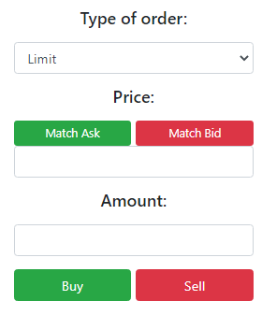

On the home page you can create an order. First, you’ll choose between Limit and Market. Then

choose your price. You can match the current ask or bid if you like. Then enter an amount. Finally, choose whether your order is a buy or sell.

When an order is created, it will enter the Buy/Sell table, and if there’s a match, your order will instantly go through!

1. Editing/Deleting an Order

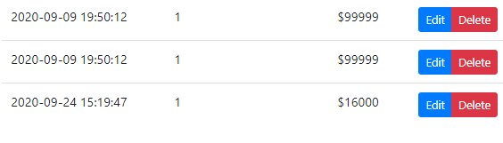

Navigate to the Manage Orders page from the top bar. Two lists will appear. The first is a list of your active orders. The second is your last ten trades. We want to use the first list, where the blue Edit button and red Delete button appear next to the order. The orders in the list have yet to complete and can be changed. If you have an incomplete order you want to edit, click the blue Edit button and you will be directed to a new page.

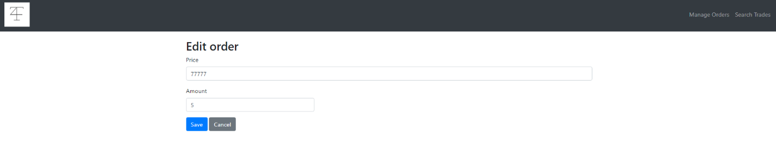

Here, you can edit the price and amount of the instrument you are buying. Click the blue Save button to complete the update or click the grey Cancel button to navigate back to the last page.

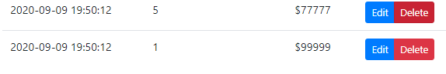

If you want to delete an order, click the red Delete button. You will be asked to confirm.

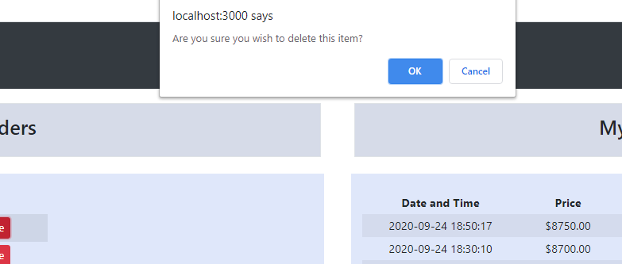

Click the blue OK button to delete your order.

1. Search Trades

Navigate to the Search Trades page from the top bar.

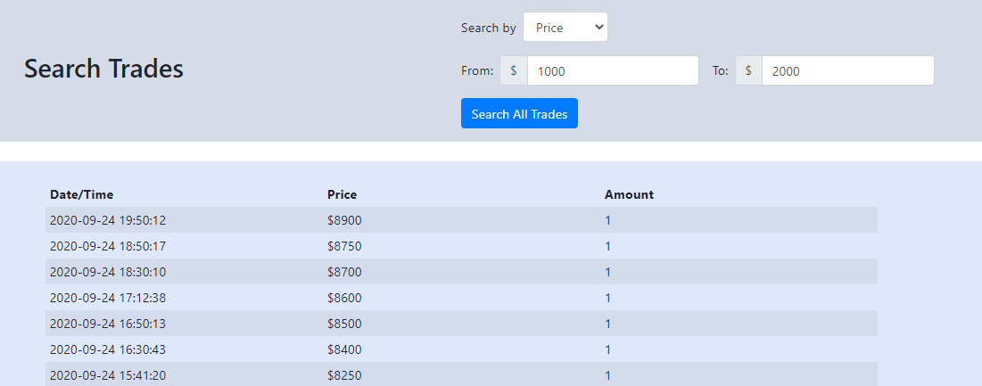

You can search by Price, Amount, or Date and Time. Use the drop down menu to choose an option.

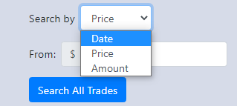

Then enter the range you would like to search within.

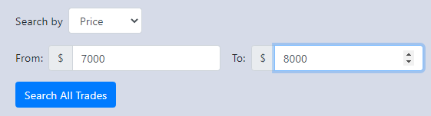

Press the blue Search All Trades button to return a list of trades.

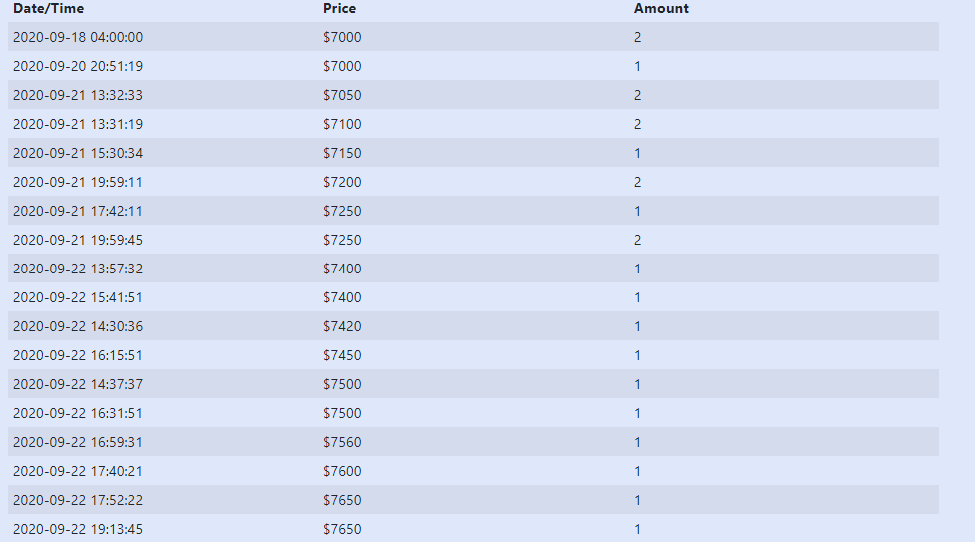

**Bonus tip**. Press the logo on the top bar to return Home.

